**👀Computer Vision | 🤔End-to-End Pipeline CV Project💡**

[[VK](https://medium.com/@VK_Venkatkumar?source=post_page-----9b8db84c7cf4--------------------------------)](https://medium.com/@VK_Venkatkumar?source=post_page-----9b8db84c7cf4--------------------------------)

[VK](https://medium.com/@VK_Venkatkumar?source=post_page-----9b8db84c7cf4--------------------------------)

·

[Follow](https://medium.com/m/signin?actionUrl=https%3A%2F%2Fmedium.com%2F_%2Fsubscribe%2Fuser%2F60f6508bffaf&operation=register&redirect=https%3A%2F%2Fmedium.com%2F%40VK_Venkatkumar%2Fcomputer-vision-end-to-end-pipeline-9b8db84c7cf4&user=VK&userId=60f6508bffaf&source=post_page-60f6508bffaf----9b8db84c7cf4---------------------post_header-----------)

5 min read

·

Nov 16, 2023

106

3

Computer vision is an interdisciplinary scientific field that deals with how computers can gain high-level understanding from digital images or videos. From the perspective of engineering,it seeks to understand and automate tasks that the human visual system can do.

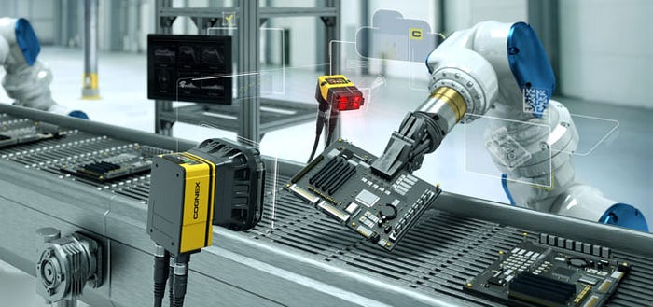

credit: Online

**Hello everyone! I’m back now, I’ll be talking about a general overview of end to end pipeline of computer vision projects.**

**Machine Vision Vs Human Vision:**

Machine vision and human vision refer to the ability of machines and humans, espectively, to perceive and interpret visual information.

Machine vision is powerful for specific tasks and can excel in speed and precision, it often lacks the versatility, adaptability, and nuanced understanding that human vision naturally possesses. Integrating the strengths of both human and machine vision can lead to more robust and effective visual perception systems.

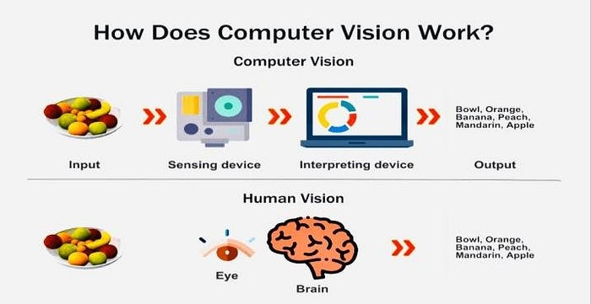

Credit: Online

**The basic workflow of a computer vision or machine vision project from throughout the process will be covered now. It’s highly desirable based on my experience.**

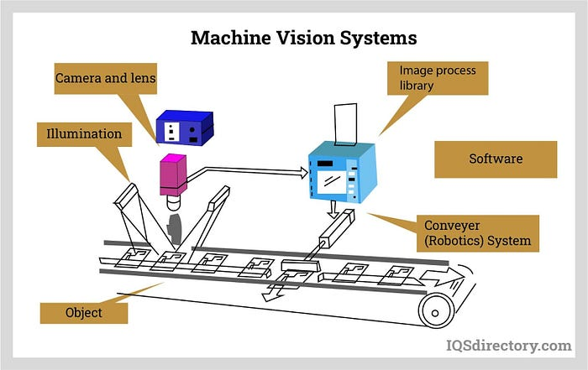

Credit: Online

**The end-to-end pipeline of a computer vision project typically involves several stages, from data collection to model deployment. Here’s a general overview of the steps involved in a computer vision project**

**Architecture:**

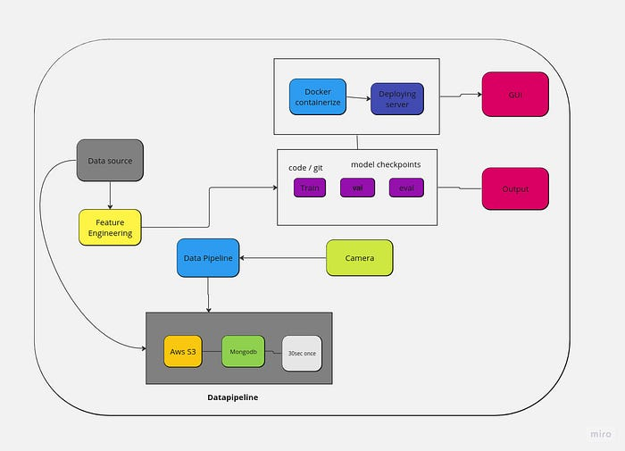

1. **Problem Definition:**

Clearly define the issue that you intend to use computer vision to tackle. Decide on the precise tasks, such as segmenting images, detecting objects in images, or classifying images. Depending on the needs of the client or the company.

**2. Data-pipeline:**

Capture images every 30 seconds with a connected camera, uploading them to an AWS S3 bucket. Simultaneously, record metadata, including timestamps, camera ID, and relevant details, into a MongoDB database. Implement error handling and periodic cleanup mechanisms, ensuring secure access controls and encryption for data in transit and at rest. Utilize unique identifiers for image filenames and establish logging and monitoring tools for system activity and issue alerts. Mindful of costs, regularly review and optimize the setup. This streamlined pipeline efficiently integrates image capture, cloud storage, and database management for a comprehensive and reliable system.

**Data Collection:** Create a dataset that is indicative of your issue. To train a reliable model, make sure the dataset contains a variety of samples. It needs to have accurate labelling and annotations based on ground truth.

**3. Building the model:**

* **Data Preprocessing and feature Engineering:**  
  Clean and preprocess the data. This may involve resizing images, normalizing pixel values, augmenting the dataset for additional variety, and handling missing or noisy data.
* **Data Splitting:**  
  Divide the dataset into three parts: training, validation, and testing. The training set is used to train the model, the validation set is used to fine-tune hyperparameters, and the test set is used to assess the model’s performance on unknown data.
* **Model Selection:**  
  Based on the complexity of your challenge, select a suitable pre-existing model architecture (e.g., Convolutional Neural Network — CNN) or develop a bespoke architecture. VGG, ResNet, YOLO and MobileNet are examples of popular pre-trained models.
* **Model Training:**  
  Train the chosen model on the training dataset using an optimization algorithm (e.g., stochastic gradient descent). Fine-tune hyperparameters and monitor the model’s performance on the validation set to prevent overfitting.
* **Model Evaluation:**  
  Evaluate the trained model on the test set to assess its generalization to new, unseen data. Metrics such as accuracy, precision, recall, and F1 score are commonly used depending on the nature of the problem.
* **Model Optimization:**  
  Optimize the model if necessary by adjusting hyperparameters, changing the model architecture, or applying techniques like pruning or quantization to reduce its size.

**4. Deployment:**

Deploy the trained model for inference on new data. This can involve integrating the model into an application, setting up a server for predictions, or deploying it on edge devices, depending on your project requirements.

**5. Monitoring and Maintenance:**

Regularly monitor the model’s performance in a production environment. If needed, retrain the model with new data to adapt to changes in the data distribution and maintain optimal performance.

**6. Documentation:**

Document the entire pipeline, including data preprocessing steps, model architecture, training parameters, and deployment details. This documentation is crucial for collaboration, reproduction, and troubleshooting.

**7. Illumination:**

Illumination in computer vision refers to the process of enhancing or adjusting the lighting conditions of an image to improve visibility and aid in subsequent computer vision tasks. Techniques for illumination in computer vision often involve image processing methods. Common approaches include histogram equalization, adaptive histogram equalization, and gamma correction.

**In my experience Lighting and environment is important role in computer vision or machine vision projects.**

Throughout the pipeline, it’s essential to iterate and experiment with different approaches to improve the model’s accuracy and efficiency. Additionally, consider ethical and privacy implications, especially when working with sensitive data or deploying models in real-world scenarios.

**The pipeline mentioned above is fundamental and is always modified to fit the particular scenario at issue. A successful AI or computer vision project involves numerous experiments. not just the creation of models. Its core connected to the end-to-end process’s core. All are dependable. If one process is unconcerned with it. The entire project has collapsed.**



credit: Online

I appreciate you coming, people. Please leave a comment if this article contains any questions or errors. or let’s connect via kaggle Conversation or LinkedIn.

***Social network :***[***linkedin***](https://www.linkedin.com/in/venkat-vk/)***,***[***Kaggle***](https://www.kaggle.com/venkatkumar001)***,***[***Github***](https://github.com/VK-Ant)

[AI](https://medium.com/tag/ai?source=post_page-----9b8db84c7cf4---------------ai-----------------)

[Computer Vision](https://medium.com/tag/computer-vision?source=post_page-----9b8db84c7cf4---------------computer_vision-----------------)

[Machine Learning](https://medium.com/tag/machine-learning?source=post_page-----9b8db84c7cf4---------------machine_learning-----------------)

[Computer Science](https://medium.com/tag/computer-science?source=post_page-----9b8db84c7cf4---------------computer_science-----------------)

[Architecture](https://medium.com/tag/architecture?source=post_page-----9b8db84c7cf4---------------architecture-----------------)